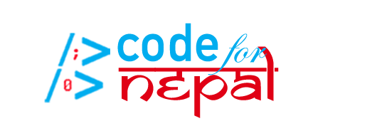

**User Documentation for Code for Nepal Website**

**By Alex John, Haley Hurst, Sean O’Connor, Katie Hibner, and Mike Kenyon**

**Table of Contents**

Introduction………………………………………………………………………………………………..3

Terminology……………………………………………………………………………………………..3-4

Documentation Instructions………………………………………………………………………4-9

How to change the language of the website…………………………………………………8-9

How to search for specific information………………………………………………………....9

How to go to a new website page…………………………………………………………………...9

How to find a test center…………………………………………………………………………..9-10

When you should seek testing…………………………………………………………….………..10

How to find a COVID-19 vaccine center…………………………………………….……..10-11

How to add a test center to the database………………………………………………….……11

How to add a vaccine center to the database……………………………………………..11-12

**1a.) Introduction**

This website prototype was created by students at Virginia Tech in an effort to make knowledge about testing and vaccines more accessible to citizens of Nepal. This website should allow users to collectively benefit from and contribute to the effort to make information about COVID-19 testing and vaccinations more accessible. After using the checklists on the “COVID-19 Information” page, the user should be able to self-evaluate their symptoms and exposure in order to establish whether or not they should seek testing or emergency medical assistance. If they find that their symptoms and exposure warrant a test, they should then be able to find their closest COVID-19 test center by utilizing the “Find a Test Center” page. If the user knows of a test center that exists but is not listed in our database, they can fill out the form on the “Add Test Centers to Database” page. If the user needs help finding transportation to test centers, they can use the resources provided on the “Transportation Resources” page for assistance.

**1b.) Terminology:**

Throughout this document, several terms referring to COVID-19, its safety mitigation, or digital literacy will be mentioned. The following terms are defined below:

* **COVID-19**:
  + The novel coronavirus that was discovered in 2019 and is the source of the international pandemic that was declared on March 11, 2020.
  + This virus sometimes presents as flu-like symptoms (a complete list of symptoms can be found on page ) and attacks the respiratory system.
* **Test Centers:**
  + Medical facilities that administer nasopharyngeal swabs can test for the presence of COVID-19 in the individual being tested.
* **Exposure:**
  + Close contact with an individual that is infected with COVID-19.
  + Close contact includes being within 1.83 meters (6 feet) from an individual who has tested positive for COVID-19 or who is displaying symptoms that align with COVID-19 symptoms.
* **Vaccine Centers:**
  + Medical facilities that administer the COVID-19 vaccine when the vaccine becomes publicly available.
* **Vaccine:**
  + A product given to an individual, usually through a shot, to provide active immunity against a specific virus.
* **Database:**
  + A collection of information.
* **Website Page:**
  + A section of the website that includes specific information.
  + Each page can be navigated to through the buttons at the top of the screen or through the menu listed at the bottom of the Home Page.
* **Text:**
  + The written content on the website prototype.

**2.) Documentation Instructions:**

This document will act as a guide for using Code for Nepal’s COVID-19 Resources website prototype. The website is separated into the following sections:

* **Home Page**
  + This is the page that you will see when you first log onto the website. It outlines the website objectives and contains buttons that will allow you to navigate to the other sections of the website, as seen in the image below.

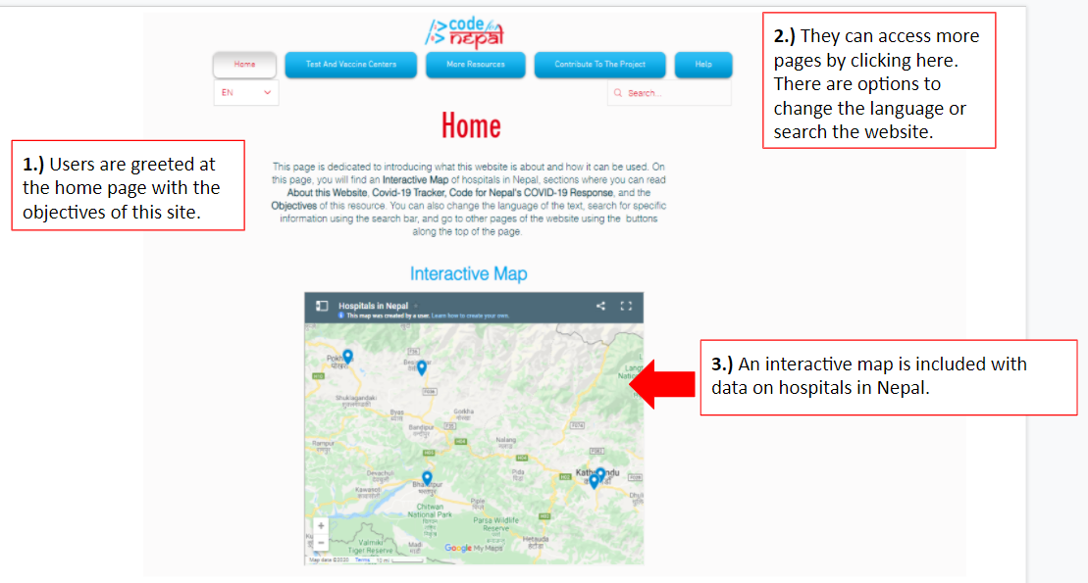

* **COVID-19 Information Page**
  + This page provides information about COVID-19 including emergency symptoms and what to do in an emergency, testing information including symptoms of COVID-19 and exposure guidelines, and the current status of a vaccine

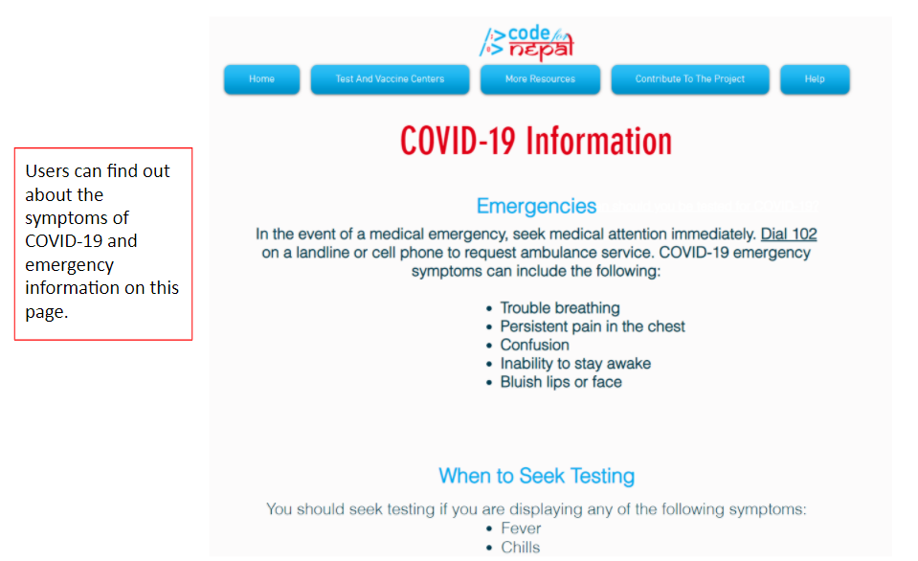

* **How to Use This Website**
  + This page goes over each of the features and functionality of each page in the website. This is shown in the picture below.
* **Find a Test Center**
  + This is the page you will use to find nearby testing centers. This is shown in the picture below.
  + You can enter the location in the search box and a testing center will appear in the map below. Instructions are also provided at the very bottom of the page.

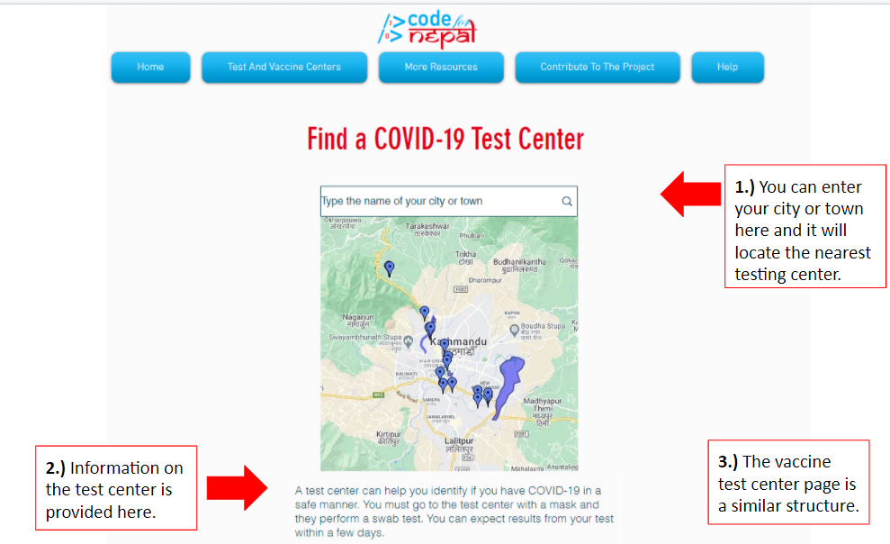

* **Add Test Centers to Database**
  + This page has a form you can fill out to report new or unlisted test centers so that we can make sure this website is up to date.
  + Instructions are provided at the bottom of this page.

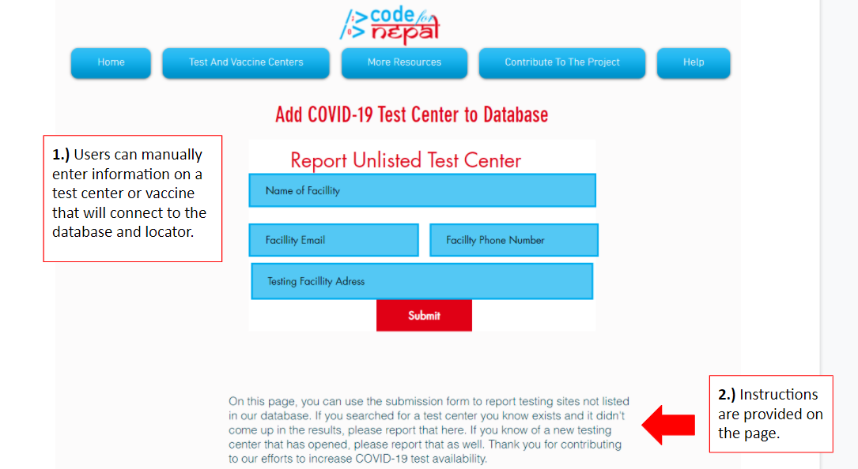

* **Transportation Resources**
  + This page contains links to transportation resources to help you get to test and vaccine centers.
  + It also has a map of bus, taxi and walking routes to major Nepalese cities.

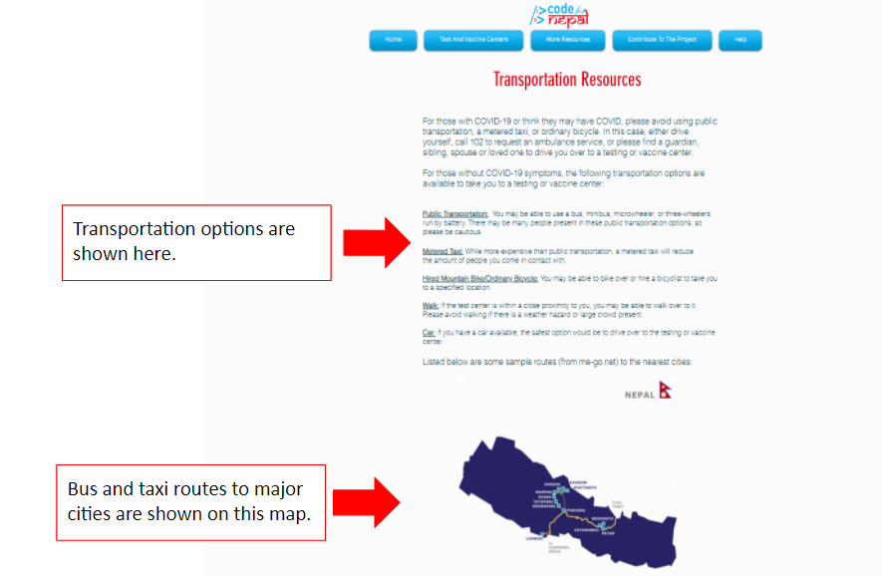

* **Test Center Database**
  + This page holds a spreadsheet of all of the known test centers in Nepal. The test center database is continuously updated, based on the feedback of the user.
* **Vaccine Center Database**
  + This page holds a list of all of the known vaccine centers in Nepal. The test center database is continuously updated, based on the feedback of the user.
  + As of December 6th, there are no vaccines currently available to the general population.
* **Additional Resources**
  + This page is used to refer you to other sources of information for COVID-19 or answer some simple questions the user may have.
  + Questions include the expected date for herd immunity, testing center costs, and more information on Code for Nepal.
* **About Code for Nepal**
  + This page, pictured below, offers more information on Code for Nepal and its mission; it has a Youtube video present and links that refer you to Code for Nepal’s website and social media.

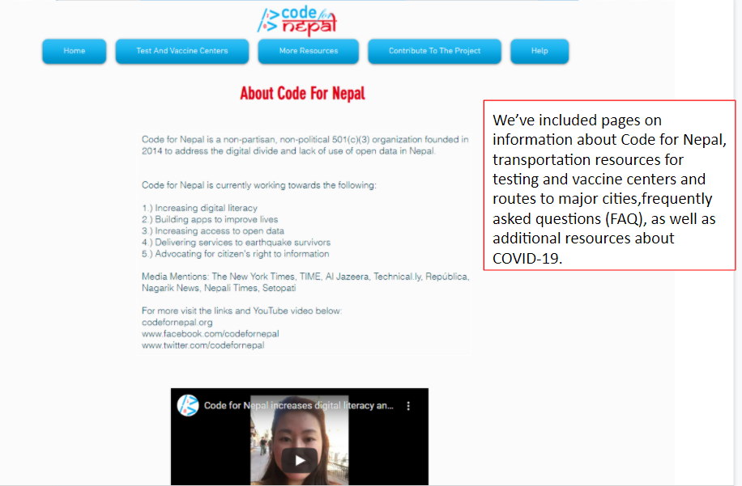

**3.) How to Change the Language of the Website:**

1. Open the Code For Nepal COVID-19 Resource Page by typing **[insert HTML link here]** into your browser. You should see this page displayed on your device.
2. In the white bar underneath the red rectangle containing **OBJECTIVES**, you should see three language options with a circular flag, pictured below.



Options include:

* 1. English
  2. Hindi
  3. Nepali

1. Click on the language you prefer. Once you click the language, the text will translate automatically.

**4.) How to Search for Specific Information:**

1. Open the Code For Nepal COVID-19 Resource Page by typing **[insert HTML link here]** into your browser. You should see this page displayed on your device.
2. Click inside the white rectangle at the top right of the screen that says **SEARCH**. This is the Search bar, pictured below.

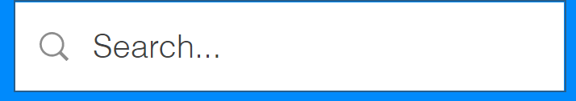

1. Type in the information you are looking for and press “Enter” on your keyboard.
2. You can repeat this process to search for new information. You can always find the Search bar in the top right.

**5.) How to Go To a New Website Page:**

Use the navigation buttons at the top of each screen:

1. At the top of your screen, locate the three buttons labelled: **HOME, COVID-19 INFORMATION, and MORE**
2. If you wish to go to the Home Page, click the **HOME** button.
3. If you wish to find information about COVID-19, click the **COVID-19 INFORMATION** button.
4. If you wish to go to another page, click the **MORE** button.
5. Click the website page you wish to go to in the menu that pops up.

**6.) How to find a test center:**

1. Open the Code For Nepal COVID-19 Resource Page by typing **[insert HTML link here]** into your browser. You should see this page displayed on your device.
2. Click the **FIND A TEST CENTER** button in the white menu on the home page.
3. Locate the search bar as indicated in the below image and place your cursor in the text box labeled **TYPE YOUR CITY OR TOWN NAME HERE.**

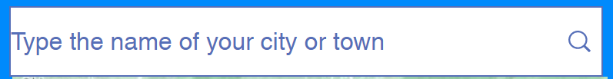

1. Type the name of your city or town in the text box.
2. Click submit to see COVID-19 test centers near you.

**7.) When you should seek testing:**

*This information can also be found on the COVID-19 Information page.*

In the event of a medical emergency, **dial 102** on a landline or cell phone to request ambulance service. COVID-19 emergency symptoms can include the following:

* Trouble breathing
* Persistent pain in the chest
* Confusion
* Inability to stay awake
* Bluish lips or face

You should seek testing if you are displaying any of the following symptoms:

* Fever
* Chills
* Nausea
* Diarrhea
* Cough
* Congestion
* Sore Throat
* Eye Pain

You should also seek testing if you have been exposed to someone displaying these symptoms or if you have been exposed to someone who has tested positive for COVID-19. Exposure is defined as fifteen minutes spent within six feet of another individual with both parties wearing masks or as one minute of ten foot proximity when neither individual is wearing masks.

**8.) How to find a COVID-19 Vaccine Center**

1. Open the Code For Nepal COVID-19 Resource Page by typing **[insert HTML link here]** into your browser. You should see this page displayed on your device.
2. Click the **FIND A VACCINE CENTER** button on the home page.
3. You should be redirected to a page that looks like this. Locate the search bar as indicated in the below image and place your cursor in the text box labeled **TYPE CITY OR TOWN NAME HERE**.

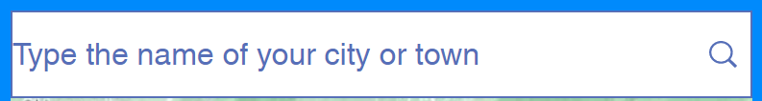

1. Type the name of your city or town in the text box.
2. Click submit to see COVID-19 vaccine centers near you.

**9.) How to add a test center to the database:**

To add a test center to our database, follow the steps below. Once you have reported a new test center, our team will evaluate your submission and add it to the database once its existence has been confirmed.

1. Open the Code For Nepal COVID-19 Resource Page by typing **[insert HTML link here]** into your browser. You should see this page displayed on your device.
2. Click the **ADD A TEST CENTER TO DATABASE**  button to go to the User Submission page.
3. Fill out this form.

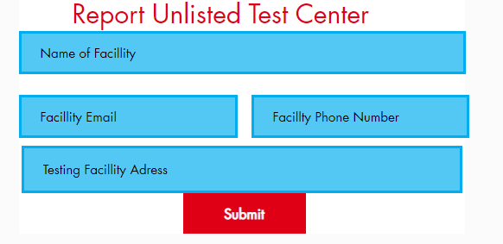

1. Click submit to share the information with the curation team.

**10.) How to add a vaccine center to the database:**

To add a vaccine center to our database, follow the steps below. Once you have reported a new test center, our team will evaluate your submission and add it to the database once its existence has been confirmed.

1. Open the Code For Nepal COVID-19 Resource Page by typing **[insert HTML link here]** into your browser. You should see this page displayed on your device.
2. Click the **ADD A VACCINE CENTER TO DATABASE**  button to go to the User Submission page.
3. Fill out the form below.

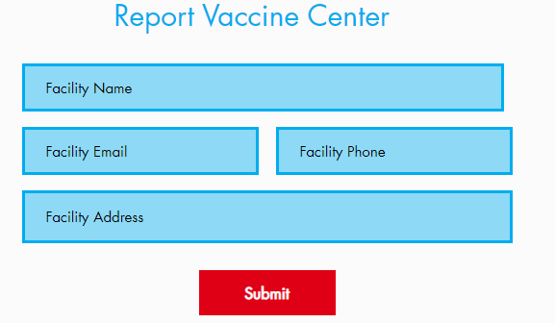

1. Click submit to share the information with the curation team.